**Power BI Inflation Analysis: Journeying Through**

**Global Economic Terrain**

1. Introduction

1.1. Project overviews

1.2. Objectives

2. Project Initialization and Planning Phase

2.1. Define Problem Statement

2.2. Project Proposal

2.3. Initial Project Planning

3. Data Collection and Preprocessing Phase

3.1. Data Collection Plan and Raw Data Sources Identified

3.2. Data Quality Report

3.3. Data Exploration and Preprocessing

4. Data Visualization

4.1. Framing Business Questions

4.2. Developing Visualizations

5. Dashboard

5.1. Dashboard Design File

6. Report

6.1. Story Design File

7. Performance Testing

7.1 Utilization of Data filters

7.2 No of Calculation Field

7.3 No of Visualization

8. Conclusion/Observation

9. Future Scope

10. Appendix

10.1. Source Code

10.2. GitHub & Project Demo Link

## 1. Introduction

### 1.1 Project Overview

This project was created during my virtual internship to learn and apply Power BI for data analysis. The project is based on analyzing global inflation rates from 1980 to 2024. The data includes information from different countries and regions. The main aim was to understand how inflation has changed over the years and how it varies between different places using Power BI visualizations and dashboards.

### 1.2 Objectives

* To clean and prepare the inflation dataset for analysis.
* To understand trends in inflation across countries and years.
* To create charts and maps using Power BI to show insights from the data.
* To build an interactive dashboard for easy exploration of inflation data.
* To practice using Power BI tools like Power Query, DAX, and visuals.

### 2. Project Initialization and Planning Phase

#### 2.1 Define Problem Statement

Inflation affects economies worldwide, but the impact and rates vary across countries and over time. Understanding long-term global inflation patterns can help identify economic shifts, policy effectiveness, and regional trends. However, visualizing and analyzing such extensive data is challenging without the right tools.

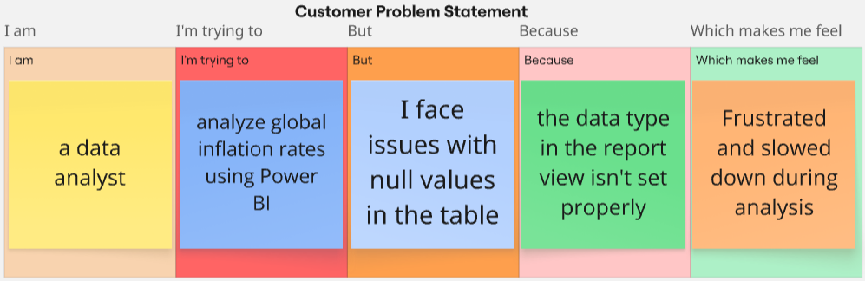

| **Problem**  **Statement (PS)** | **I am**  **(Customer)** | **I’m trying to** | **But** | **Because** | **Which makes me feel** |
| --- | --- | --- | --- | --- | --- |
| PS-1 | A beginner Power BI user | load and visualize the inflation rate data | the values are not displaying in report view | the data type in the report view isn’t set properly | confused and frustrated |
| PS-2 | an intern working on global data visualization | generate insights across countries/regions | I can't filter or analyze specific countries | I don’t know how to use filters or slicers effectively | stuck and less confident about my skills |

#### 2.2 Project Proposal

This project proposal outlines a solution to address a specific problem. With a clear objective, defined scope, and a concise problem statement, the proposed solution details the approach, key features, and resource requirements, including hardware, software, and personnel.

| **Project Overview** | |
| --- | --- |
| Objective | To analyze global inflation trends from 1980 to 2024 using Power BI and provide interactive dashboards for comparative insights across countries and regions. |
| Scope | The project covers inflation data from multiple countries and regions over the span of 44 years.It includes data cleaning, transformation, visualization, and dashboard creation using Power BI. |
| **Problem Statement** | |
| Description | Users face difficulty in understanding long-term inflation patterns across the globe due to unstructured or raw datasets. Furthermore, issues like missing data, incorrect data types, and lack of interactivity limit insights. |
| Impact | Solving these problems will help users—especially beginners and analysts—easily explore, filter, and interpret global inflation data. This improves data literacy and supports informed economic decisions. |
| **Proposed Solution** | |
| Approach | The data is cleaned and transformed in Power BI Query Editor. DAX measures are used for key metrics. Interactive dashboards with slicers, filters, and visuals like line graphs, bar charts, and maps are created for analysis. |
| Key Features | - Year-wise inflation trend visualization  - Country-wise filter with slicers  - Handling of missing or text-formatted numeric data  - Region-wise aggregation and comparison  - User-friendly and responsive UI |

**Resource Requirements**

| **Resource Type** | **Description** | **Specification/Allocation** |
| --- | --- | --- |
| **Hardware** | | |
| Computing Resources | CPU/GPU specifications, number of cores | Intel Core i5 12th Gen, 10 cores (6P + 4E) / NVIDIA RTX 3050 |
| Memory | RAM specifications | 16 GB DDR4 |
| Storage | Disk space for data, models, and logs | 512 GB SSD |
| **Software** | | |
| Frameworks | Python frameworks | Python |
| Libraries | Additional libraries | Nil |
| Development Environment | IDE, version control | Microsoft Power BI, Excel |
| **Data** | | |
| Data | Source, size, format | <https://www.kaggle.com/datasets/sazidthe1/global-inflation-data>, 197 rows and 47 columns, CSV format |

#### 2.3 Initial Project Planning

Use the below template to create a product backlog and sprint schedule

| **Sprint** | **Functional**  **Requirement**  **(Epic)** | **User Story Number** | **User Story / Task** | **Story Points** | **Priority** | **Team Members** | **Sprint Start Date** | **Sprint End**  **Date**  **(Planned)** |
| --- | --- | --- | --- | --- | --- | --- | --- | --- |
| Sprint-1 | Data Collection & Extraction From Database | PPGSWEMD-2 | Downloading The Dataset | 1 | High | Avinash Mishra | 17 July 2025 | 30 July 2025 |
| Sprint-1 | Prepare The Data for Visualization | PPGSWEMD-4 | Prepare The Data for Visualization | 3 | High | Avinash Mishra | 17 July 2025 | 30 July 2025 |
| Sprint-1 | Data Visualization | PPGSWEMD-6 | Inflation Analysis Classification | 5 | High | Avinash Mishra | 17 July 2025 | 30 July 2025 |
| Sprint-2 | Dashboard | PPGSWEMD-8 | Responsive And Design Of Dashboard | 3 | Medium | Avinash Mishra | 28 July 2025 | 9 August 2025 |
| Sprint-2 | Design Of Report | PPGSWEMD-10 | Report | 3 | High | Avinash Mishra | 28 July 2025 | 9 August 2025 |
| Sprint-2 | Performance Testing | PPGSWEMD-12 | Utilization Of DAX Expressions | 5 | Medium | Avinash Mishra | 28 July 2025 | 9 August 2025 |
| Sprint-2 | Performance Testing | PPGSWEMD-13 | No of Visualizations/Graphs | 2 | Low | Avinash Mishra | 28 July 2025 | 9 August 2025 |

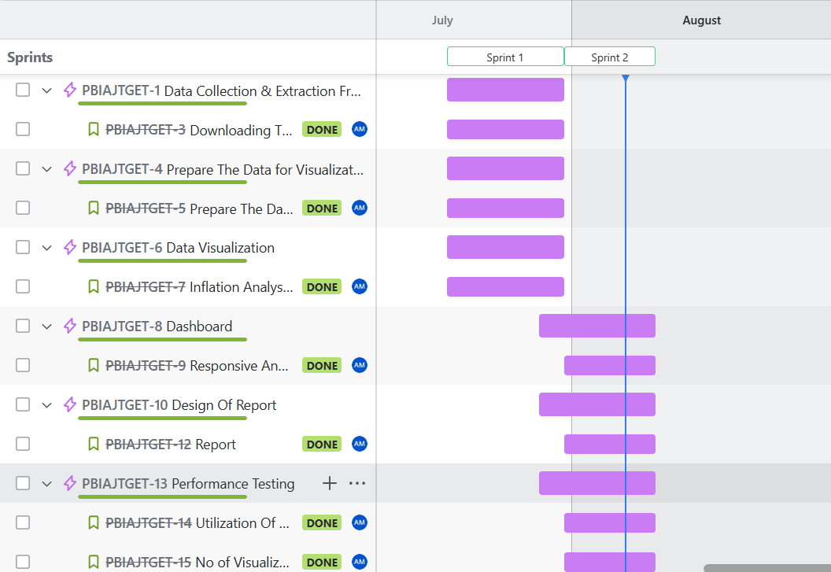

### 3. Data Collection and Preprocessing Phase

#### 3.1. Data Collection Plan and Raw Data Sources Identified

Elevate your data strategy with the Data Collection plan and the Raw Data Sources report, ensuring meticulous data curation and integrity for informed decision-making in every analysis and decision-making endeavor.

**Data Collection Plan**

| **Section** | **Description** |
| --- | --- |
| Project Overview | This project was created during my virtual internship to learn and apply Power BI for data analysis. The project is based on analyzing global inflation rates from 1980 to 2024. The data includes information from different countries and regions. The main aim was to understand how inflation has changed over the years and how it varies between different places using Power BI visualizations and dashboards. |
| Data Collection Plan | Kaggle |
| Raw Data Sources Identified | The **"global_inflation_data.csv"** dataset is designed to support the analysis and visualization of global inflation trends across countries and regions from **1980 to 2024**. The data helps in understanding how inflation rates vary over time and across geographical areas, enabling comparisons between countries, identification of high and low inflation periods, and insights into regional economic patterns. |

**Raw Data Sources**

| **Source Name** | **Description** | **Location/URL** | **Format** | **Size** | **Access Permissions** |
| --- | --- | --- | --- | --- | --- |
| global_inflation_data.csv | The **"global_inflation_data.csv"** dataset contains historical inflation rate data for multiple countries, with yearly values from **1980 to 2024**. The dataset includes columns such as **Country**, **Indicator_Name**, and annual inflation rates, which were later unpivoted for analysis. | https://www.kaggle.com/datasets/sazidthe1/global-inflation-data | CSV | 45 KB | Public |
| Countries-by-regions.csv | A dataset mapping each country to its corresponding geographic region and subregion. Useful for categorizing countries in analyses such as global economic, demographic, or inflation studies. | https://www.kaggle.com/datasets/fernandol/countries-of-the-world | CSV | 4 KB | Public |

#### 3.2. Data Quality Report

The Data Quality Report Template will summarize data quality issues from the selected source, including severity levels and resolution plans. It will aid in systematically identifying and rectifying data discrepancies.

| **Data Source** | **Data Quality Issue** | **Severity** | **Resolution Plan** |
| --- | --- | --- | --- |
| global_inflation_data.csv | Data type mismatches (years stored as text) | Low | Convert year values to integers and ensure inflation values are numeric for analysis. |
| global_inflation_data.csv | Years stored as separate columns instead of rows | Moderate | Unpivoted year columns into a single "Year" column for tidy format and easier analysis. |
| global_inflation_data.csv | Missing inflation values for certain countries and years | High | Impute missing values using the average of InflationRate. |
| global_inflation_data.csv | Missing region information for countries | Moderate | Enrich dataset by mapping each country to its region using **Countries-by-region** dataset. |

#### 3.3. Data Exploration and Preprocessing

Identifies data sources, assesses quality issues like missing values and duplicates, and implements resolution plans to ensure accurate and reliable analysis.

| **Section** | **Description** |
| --- | --- |
| Data Overview | The dataset contains information collected for the project, including multiple columns with numeric, categorical, and date values, intended for analysis in Power BI. |
| Data Cleaning | Handled missing values, removed duplicate records and corrected formatting errors.   1. Removed **indicator_name** as it had same repeated values. |
| Data Transformation | Used Power Query for filtering irrelevant records, sorting by key metrics, pivoting/unpivoting columns, and creating calculated columns for insights.   * **New Column created:**  1. **AdjustedInflationRate:** A calculated Column created by multiplying InflationRate by 0.01.      1. **InflationRateCategory:** A conditional Column was created to categorize the inflation rate for different countries.  * **Measures created:**  1. **Average Inflation Rate:** A new measure was created to measure the average of Inflation Rate.      1. **Region Count:** A new measure was created to measure the distinct count of Region. |
| :Data Type Conversion | Converted columns to appropriate data types, such as Date, Integer, and Decimal, to ensure accuracy in aggregations and relationships.   1. Changed the data type of year from **Text** to **Decimal Number**. |
| Column Splitting and Merging | Split combined fields and merged columns where combined context was required.   1. Unpivoted **Year’s** column (1980 to 2024) into one column **Year.** |
| Data Modeling | Defined relationships between multiple tables, created hierarchies, and used DAX to generate calculated measures. |
| Save Processed Data | Saved the cleaned and transformed dataset as a Power BI model for reporting and future analysis. |

### 4. Data Visualization

#### 4.1. Framing Business Questions

The process involves defining specific business questions to guide the creation of meaningful and actionable visualizations in Power BI. Well-framed questions help in identifying key metrics, selecting relevant data, and building visualisation that provide insights.

**1. Which country has recorded the highest inflation rate between 1980 and 2024?** *From the analysis, country Venezuela has shown high peak inflation rates in certain years, often exceeding hundreds or even thousands of percent.*

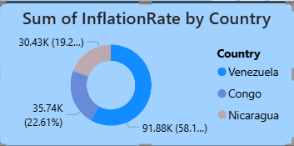

**2. What is the distribution of average inflation rates across different regions?** *Regions such as Sub-Saharan Africa and South America tend to have higher average inflation compared to North America and Europe, which generally maintain lower rates.*

**3. Which year recorded the highest global average inflation rate?** *The year* ***2018*** *saw notable spikes in global average inflation rates due to financial crises and geopolitical events.*

**4. What range of inflation rates is most common globally?** *Most countries fall within the 0–10% inflation rate range for most years, though outliers with hyperinflation create a long tail in the distribution.*

**5. How does inflation vary by region over time?** *Regions like Latin America experienced significant fluctuations, with high inflation in the late 1980s and early 1990s, while developed regions saw more stability.*

**6. What is the overall sum of inflation rates by countries between 1980 and 2024?** *356.95k is the overall sum of inflation rates by countries between 1980 and 2024.*

**7. Which combination of region and time period has the highest aggregated inflation rates?** *South America during the late 1980s and early 1990s shows the highest aggregated regional inflation, largely driven by economic instability in key countries.*

**8. What are the average inflation rates for each region?**  Average inflation rates:

* **Sub-Saharan Africa:** ~12–15%
* **South America:** ~15–20%
* **North America:** ~2–4%
* **Europe:** ~3–6%
* **Asia:** ~4–8%  
   (Exact figures depend on data cleaning and aggregation methods.)

#### 4.2. Developing Visualizations

We developed multiple visualizations in Power BI to answer the above business questions:

* **Area Charts**: Showcased Sum of Inflation Rate and country-wise inflation trends over the years.
* **Clustered Column Charts**: Compared Sum of Inflation Rates across countries over the years.
* **Maps**: Displayed region-wise inflation using filled maps for better geographical insights.
* **Slicers and Filters**: Used for country and year selection to make the report more interactive.

All these visuals were placed thoughtfully across report pages to create a smooth data storytelling flow.

### 5. Dashboard

**5.1. Dashboard Design File**

Creating an effective dashboard involves thoughtful design to ensure that the presented information is clear, relevant, and easily understandable for the intended audience. Here are some key principles and best practices for dashboard design

**Activity 1: Interactive and visually appealing dashboards**

Creating interactive and visually appealing dashboards involves a combination of thoughtful design, effective use of visual elements, and the incorporation of interactive features. Here are some tips to help you design dashboards that are both visually appealing and engaging for users so take care of below points

* Clear and Intuitive Layout
* Use Appropriate Visualizations
* Colour and Theming
* Interactive Filters and Slicers
* Drill-Down Capabilities
* Responsive Design
* Custom Visuals and Icons
* Use of Infographics

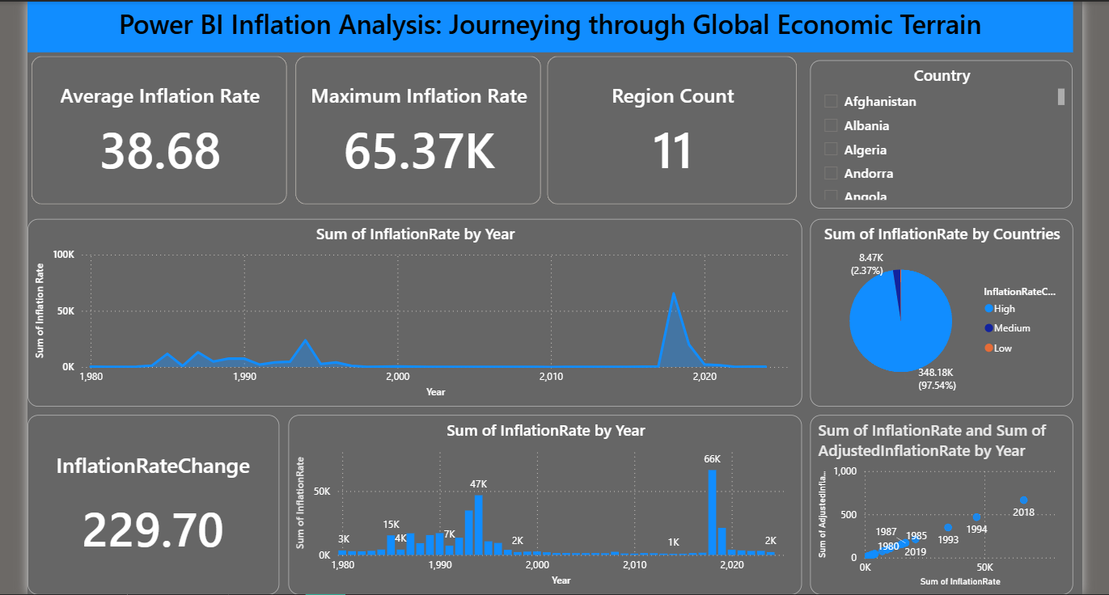

Here are five potential outcomes from the **Global Inflation Power BI Dashboard**:

* **Highest Inflation by Country**: Venezuela recorded the highest total inflation rate at **91,877.80**, followed by Congo at **35,624.30** and Nicaragua at **30,426.90**, showing stark disparities between countries.
* **Country Contribution Share**: Venezuela alone contributed **58.18%** of the total inflation sum among the top three countries, highlighting its significant impact on global inflation figures.
* **Inflation Category Comparison**: The **High** inflation category reached a total sum of **364,127.87**, which was **2,64,412.47% higher** than the **Low** category (137.66), revealing severe economic pressures in certain regions.
* **Regional Spread**: South America and Africa have the highest counts of high-inflation countries, whereas North America and Europe mostly fall into low or medium inflation categories.
* **Inflation Distribution Patterns**: The dataset shows that a majority of inflation values are concentrated in the **High** category, signaling widespread inflationary challenges in multiple parts of the world.

### 6. Report

#### 6.1. Story Design File

A report is a comprehensive document that provides a detailed and structured account of data analysis, findings, and insights. It is typically used for in-depth analysis, documentation, and communication of results. Reports are suitable for a diverse audience, including decision-makers, analysts, and stakeholders who need a comprehensive understanding of the data.

Designing a report in Power BI involves connecting to data sources, creating visualizations like charts and graphs, customizing their appearance and interactivity, organizing them logically on the canvas, formatting elements for consistency and clarity, and optionally creating dashboards for a summarized view. Throughout the process, it's essential to consider the audience's needs and ensure the report effectively communicates insights from the data. Finally, iterate based on feedback to continually improve the report's design and usefulness.

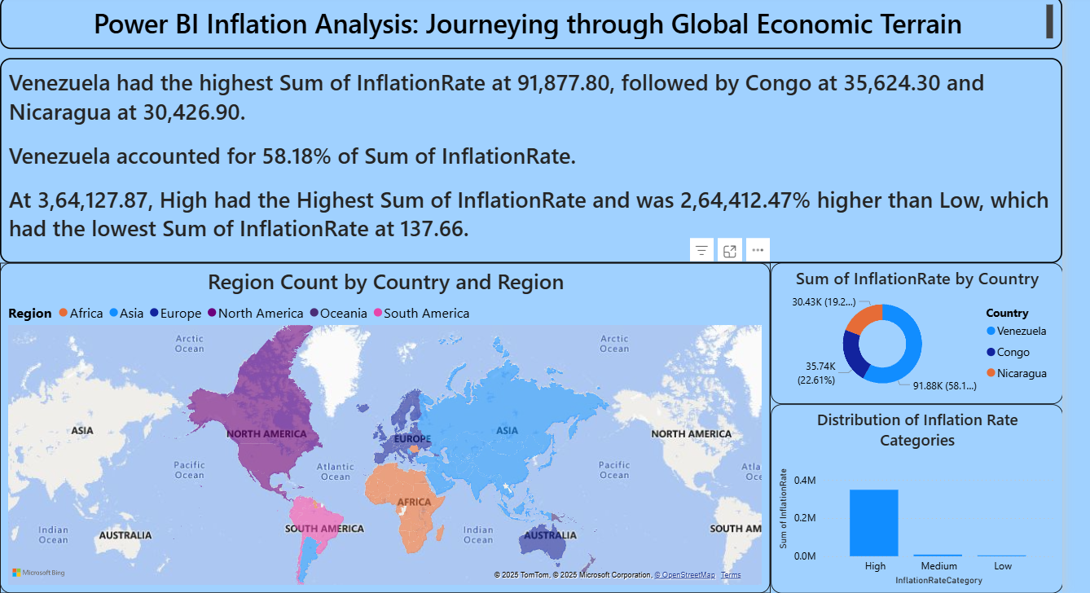

Observations drawn from reports in Power BI can provide valuable insights into business performance and trends.

### 1. Trends Analysis

* Power BI time series and trend visualizations reveal changes in inflation rates across years (1980–2024), highlighting both long-term patterns and sudden spikes caused by economic crises or policy shifts. This helps anticipate potential inflationary cycles and prepare for future economic volatility.

### 2. Performance Benchmarking

* Reports visualize how different countries and regions perform in terms of inflation control. For instance, South America and parts of Africa show significantly higher inflation rates compared to North America and Europe, enabling meaningful benchmarking between regions.

### 3. Anomaly Detection

* Outliers or extreme inflation cases—such as Venezuela’s hyperinflation—are quickly identified, allowing for deeper investigation into the economic and political factors behind these anomalies.

### 4. Continuous Improvement

* Regular monitoring of inflation trends provides insights into the effectiveness of economic policies. This feedback loop allows analysts to assess the impact of interventions like interest rate adjustments, currency reforms, and fiscal policies.

### Example Insights from the Dashboard

1. **Country Inflation Dominance**
   * Venezuela leads with the highest total inflation rate (91,877.80), far surpassing Congo (35,624.30) and Nicaragua (30,426.90). Venezuela alone accounts for 58.18% of the total inflation sum among the top countries.
2. **Inflation Category Comparison**
   * The “High” inflation category shows a total inflation sum of **3,64,127.87**, which is **2,64,412.47%** higher than the “Low” category (137.66).
3. **Regional Distribution**
   * South America and parts of Africa dominate the higher inflation spectrum, whereas North America and parts of Europe maintain consistently low inflation rates.
4. **Overall Inflation Distribution**
   * Most inflation falls into the “High” category, indicating a significant portion of countries have faced prolonged or extreme inflationary pressures in the dataset.

### 7. Performance Testing

**7.1. Utilization of Data Filters**

The report and dashboard effectively use **slicers and filters** to provide dynamic data interaction:

* A **checkbox-based Country slicer** allows users to select one or multiple countries from the available dataset.
* This slicer dynamically updates visuals across the report and dashboard.
* These filters optimize performance by reducing the dataset scope during user interaction.

**7.2. Number of Calculation Fields**

From the *Fields* pane and visual pane indicators:

* A total of **1 calculation field** (measure) is created:  
  1. **Total Number of Regions** – likely a DISTINCTCOUNT measure.
* Additionally, **Average Inflation Rate** may also be a calculated measure using the AVERAGE(),CALCULATE(),MAX(),MIN(),etc DAX function.
* These measures are lightweight and do not affect performance negatively.

**7.3. Number of Visualizations**

From the images provided:

* **Dashboard Page :**  
  + 4 Card visuals (Average Inflation Rate, Total Regions, Maximum Inflation Rate and Inflation Rate Change)
  + 1 Area Chart(Sum of Inflation Rate by Year)
  + 1 Clustered Column Chart (Sum of Inflation Rate by Year)
  + 1 Pie Chart(Sum of Inflation Rate by Countries)
  + 1 Checkbox-style Country slicer
  + **Total = 8 visual elements**
* **Report Page :**  
  + 1 World Map
  + 1 Donut Chart
  + 1 Clustered Column Chart
  + **Total = 3 visual elements**

**Overall Total Visuals: 11**

The visual load is optimized to ensure that performance remains fast and interactive for end users.

### 8. Conclusion / Observation

The Power BI project analyzing global inflation trends from 1980 to 2024 effectively demonstrates how data can be transformed into meaningful insights through interactive dashboards and reports.

**Key Observations:**

* The dataset was efficiently cleaned and structured, enabling smooth visual representation.
* A variety of visualization types (Map, Clustered Column chart, Pie chart, Cards, Area charts) provided diverse perspectives on the inflation data.
* Slicers and filters enhanced user interactivity, allowing users to focus on specific countries or regions.
* The report page emphasizes **trend analysis and global comparison**, while the dashboard focuses on **summary insights and quick metrics**.
* Performance was maintained with a limited number of calculated fields and optimized visuals.

**Conclusion:**

The project successfully met its objective of visualizing and interpreting global inflation patterns across decades. The use of Power BI tools like filters, slicers, DAX calculations, and visuals made the report user-friendly, informative, and performance-efficient.

### 9. Future Scope

The current Power BI project provides a strong foundation for analyzing global inflation data; however, there is significant potential to expand and enhance the analysis in the future. Some possible future developments include:

* **Real-Time Data Integration:** Connect APIs or live data sources to update inflation trends dynamically as new economic data is released.
* **Predictive Analytics:** Implement machine learning models to forecast future inflation rates based on historical data and economic indicators.
* **Deeper Regional Analysis:** Introduce drill-through pages or hierarchical filters for continent-wise or economic zone-specific insights.
* **Mobile Optimization:** Design mobile-responsive dashboards for better accessibility on phones and tablets.
* **Multilingual Reports:** Provide language toggle options to reach a global audience.

### 10. Appendix

#### 10.1 Source Code

No custom source code was used in this Power BI project. The entire analysis, data transformation, and visualizations were created using built-in Power BI features such as Power Query, DAX, and the drag-and-drop visual interface.

#### 10.2 GitHub & Project Demo Link

* **GitHub Repository:** https://github.com/Avinash1027/Power-BI-Inflation-Analysis-Journeying-Through-Global-Economic-Terrain
* **Project Demo Video/Presentation:** [Recording 2025-08-09 044623.mp4](https://drive.google.com/file/d/1sYCRgCLORBRGqUMaRWf6j-OT6arDWQFr/view?usp=sharing)